FUNCTIONAL AND NON-FUNCTIONAL TESTING

Module Name: E-Commerce Website - Login Module Test Case (Automation Exercise)
Test Case ID: TC001
Tester Name: Chouhan Himansu Raj singh

Test Scenarios:
● Scenario ID: 1a
Scenario: Login with valid email and password
Test Steps:
1. Open the Automation Exercise website
2. Click 'Signup / Login'
3. Enter Email
4. Enter Password
5. Click Login
Screenshots:
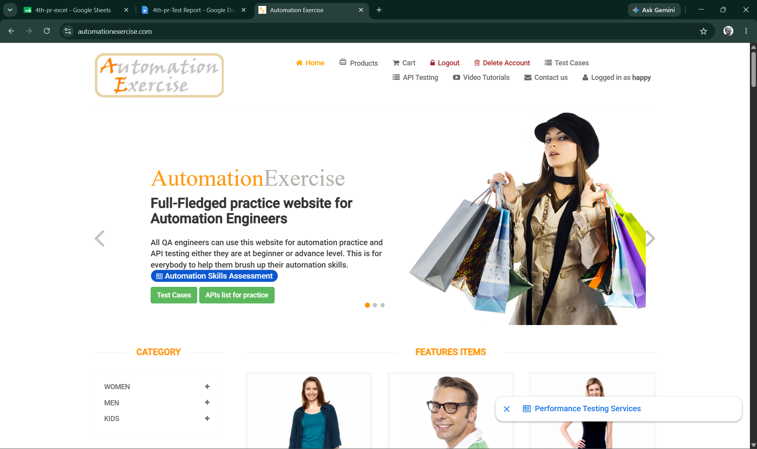
● Scenario ID: 1b
Scenario: Login with invalid email, valid password
Test Steps:
1. Open the Automation Exercise website
2. Click 'Signup / Login'
3. Enter Email
4. Enter Password
5. Click Login
Screenshots: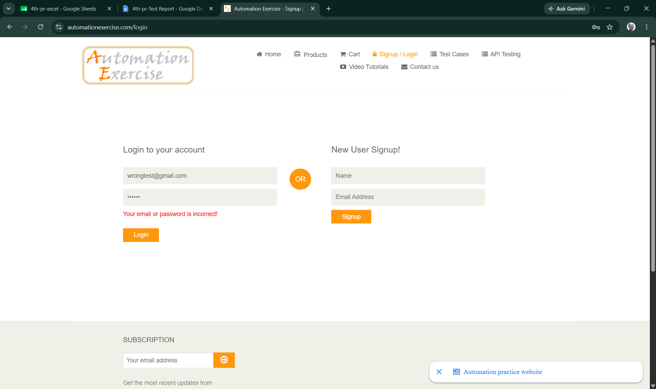

● Scenario ID: 1c
Scenario: Login with valid email, invalid password
Test Steps:
1. Open the Automation Exercise website
2. Click 'Signup / Login'
3. Enter Email
4. Enter Password
5. Click Login
Screenshots:
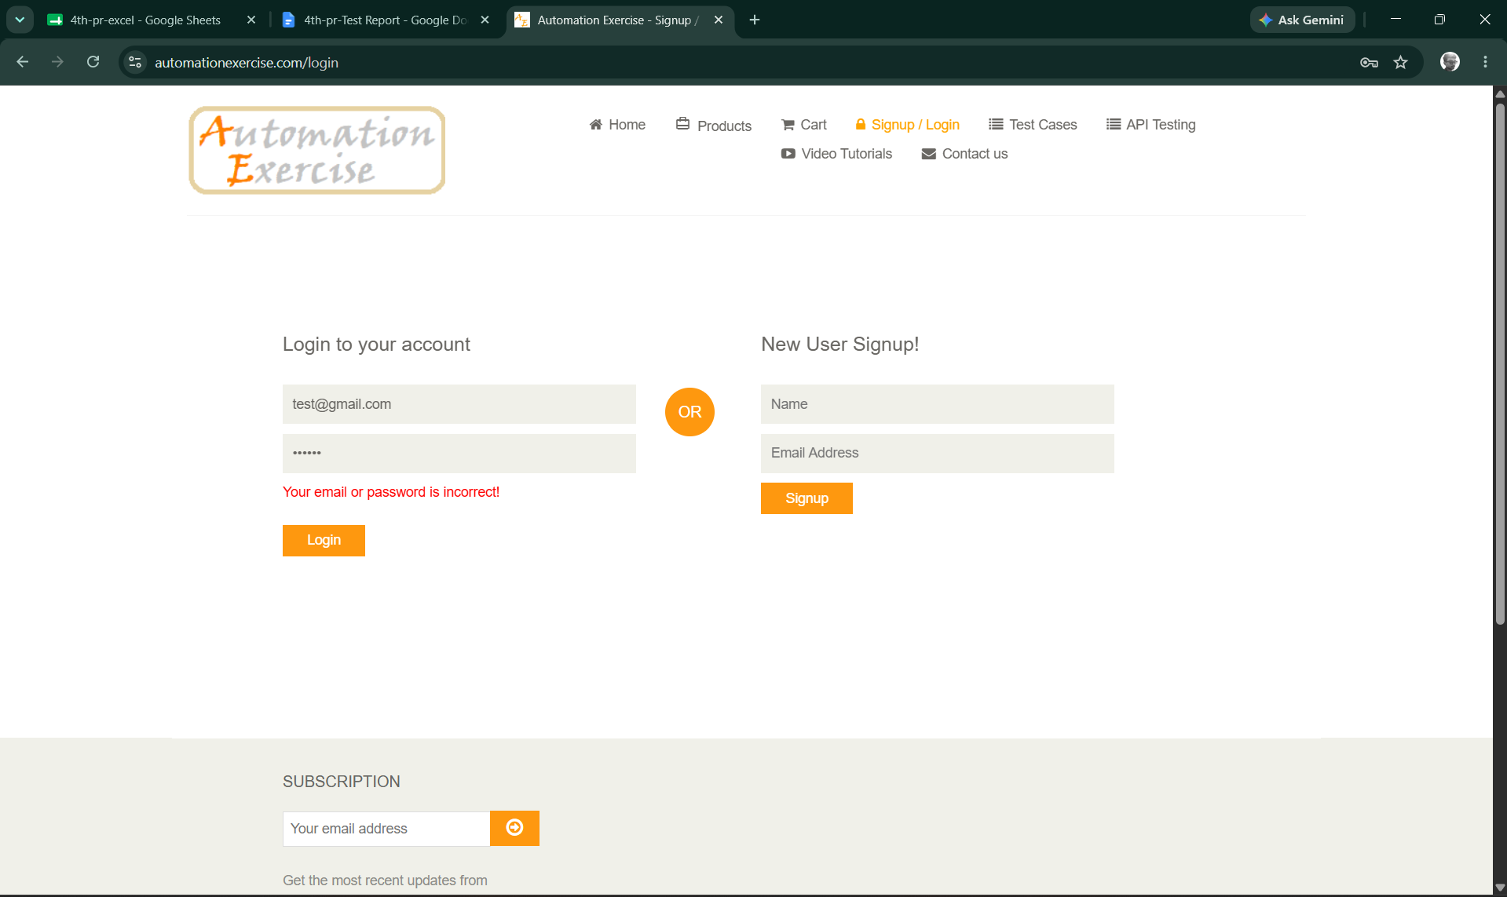

● Scenario ID: 1d
Scenario: Login with invalid email and invalid password
Test Steps:
1. Open the Automation Exercise website
2. Click 'Signup / Login'
3. Enter Email
4. Enter Password
5. Click Login

Screenshots:

● Scenario ID: 1e
Scenario: Login with blank email, valid password
Test Steps:
1. Open the Automation Exercise website
2. Click 'Signup / Login'
3. Leave Email blank
4. Enter Password
5. Click Login
Screenshots:
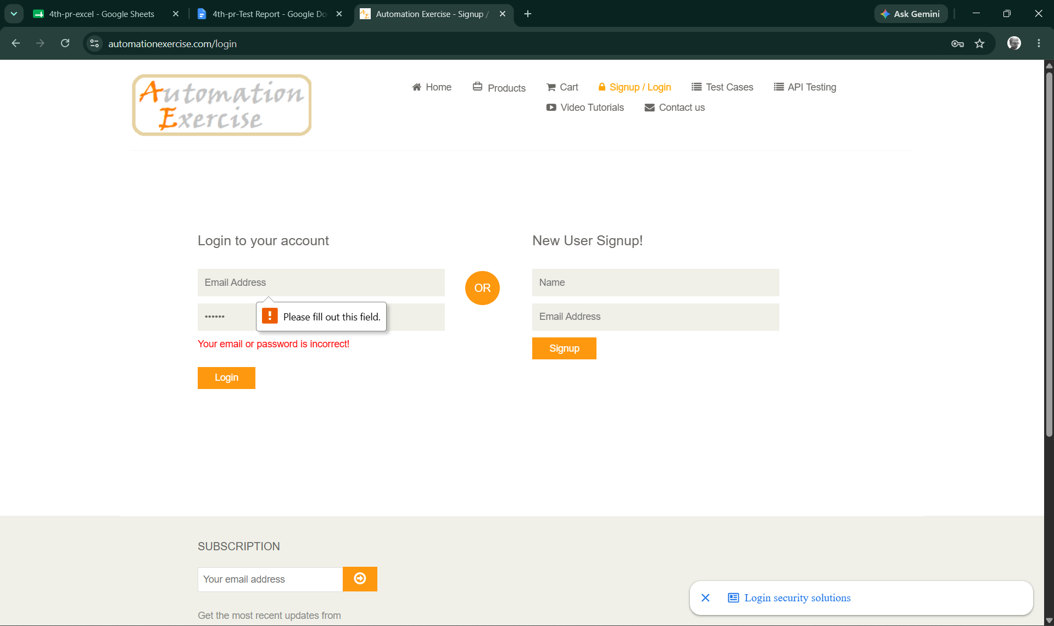

● Scenario ID: 1f
Scenario: Login with valid email, blank password
Test Steps:
1. Open the Automation Exercise website
2. Click 'Signup / Login'
3. Enter Email
4. Leave Password blank
5. Click Login
Screenshots:
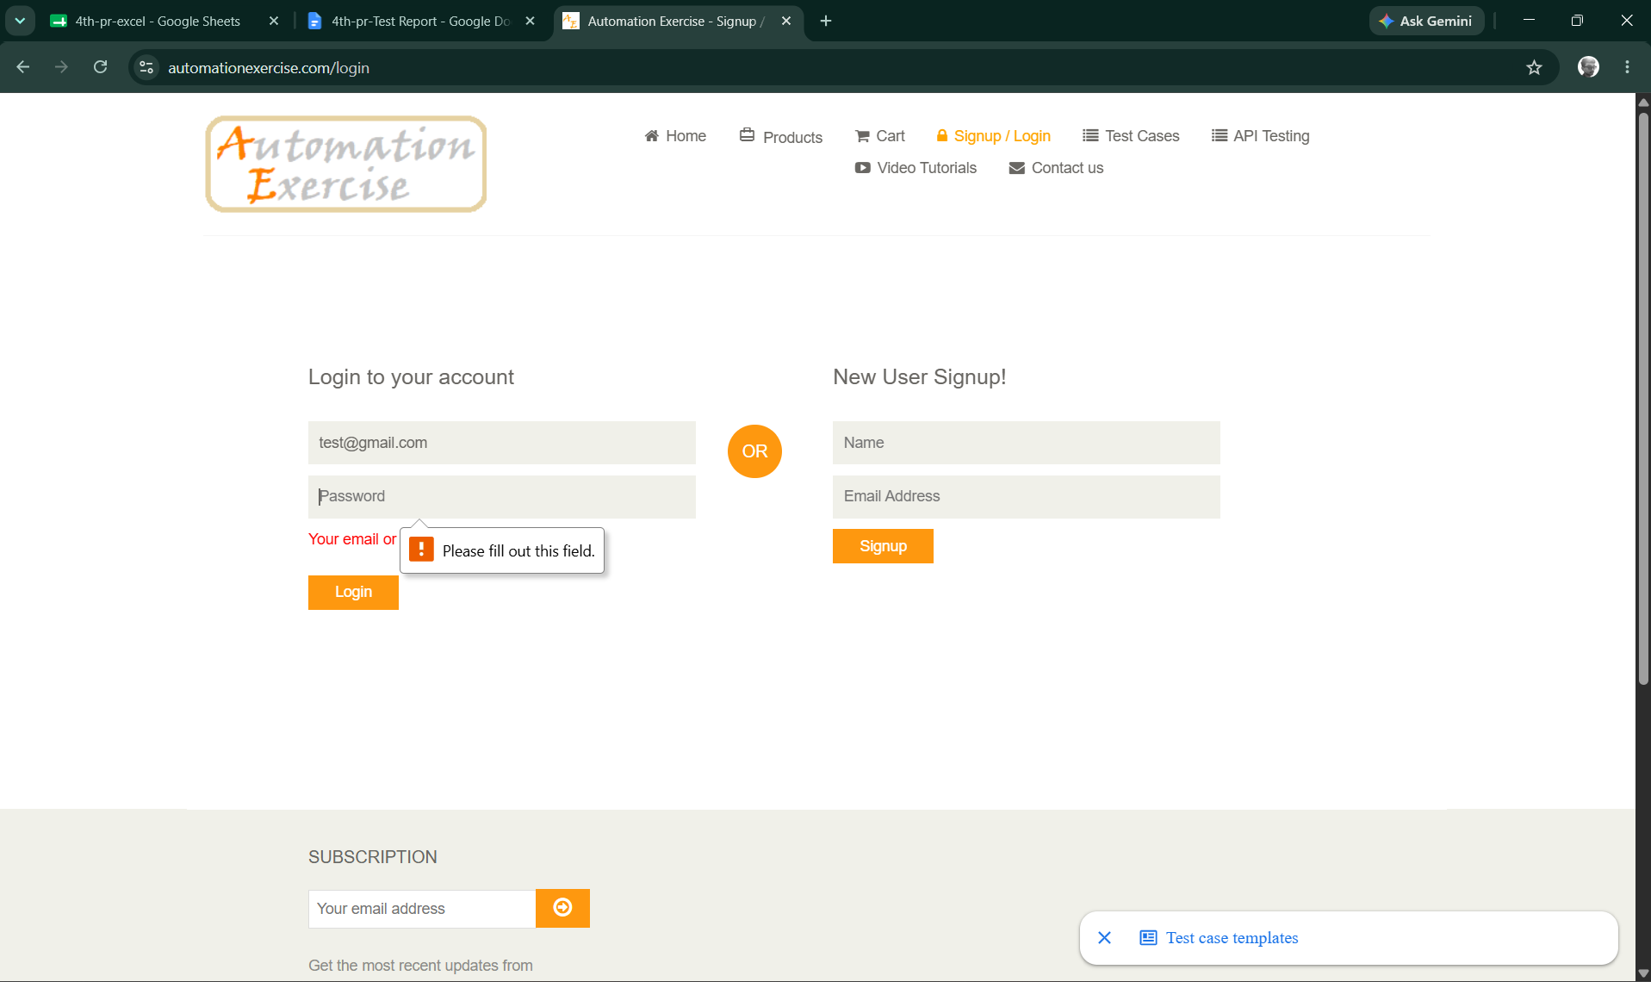

● Scenario ID: 1g
Scenario: Login with blank email and blank password
Test Steps:
1. Open the Automation Exercise website
2. Click 'Signup / Login'
3. Leave Email blank
4. Leave Password blank
5. Click Login
Screenshots:
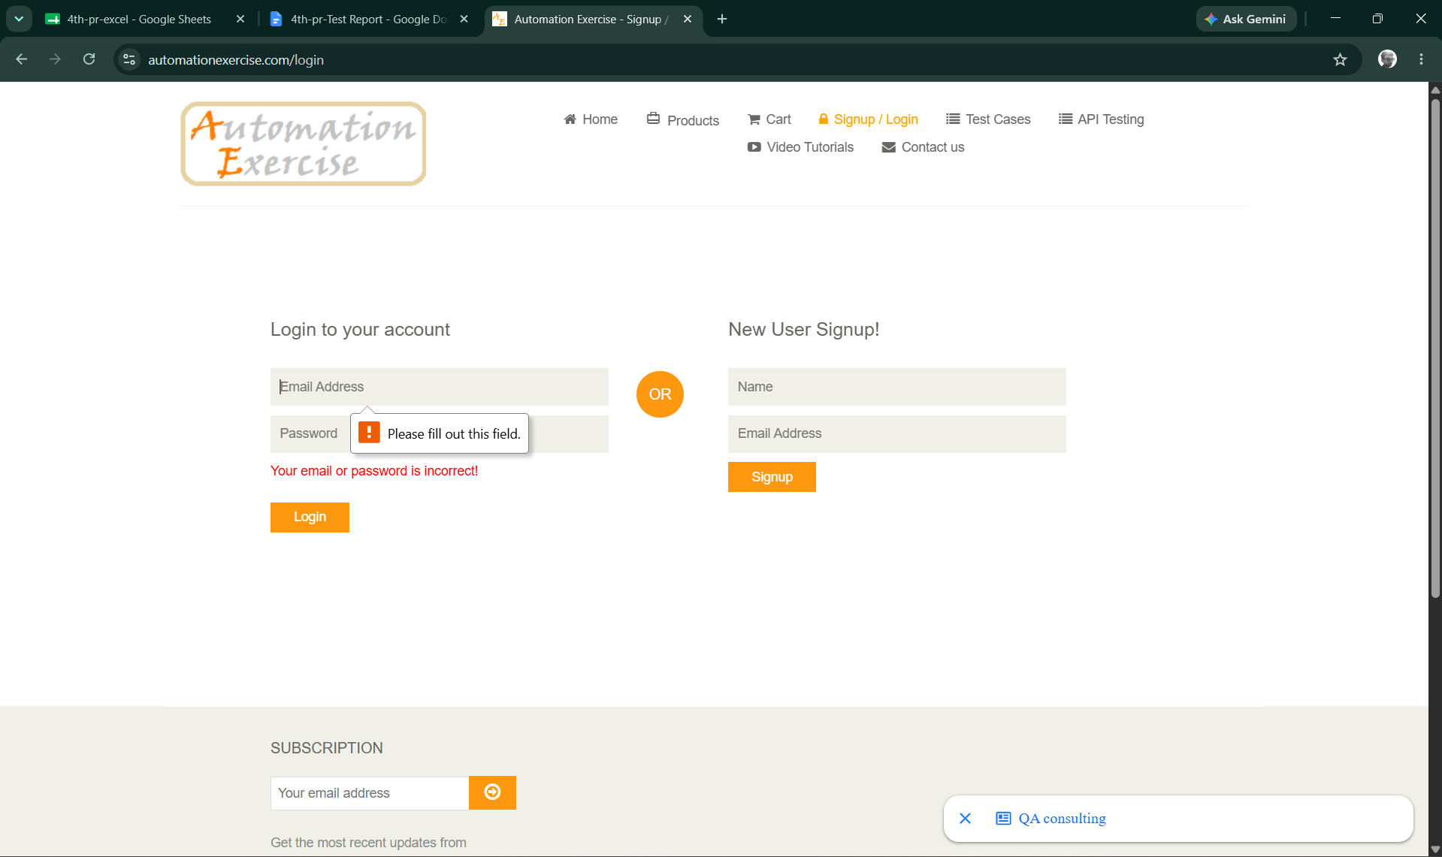

● Scenario ID: 1h
Scenario: Browser compatibility check on Login page
Test Steps:
1. Open the Automation Exercise website in Chrome
2. Repeat in Firefox
3. Repeat in Edge
4. Verify Login page renders correctly in each
Screenshots: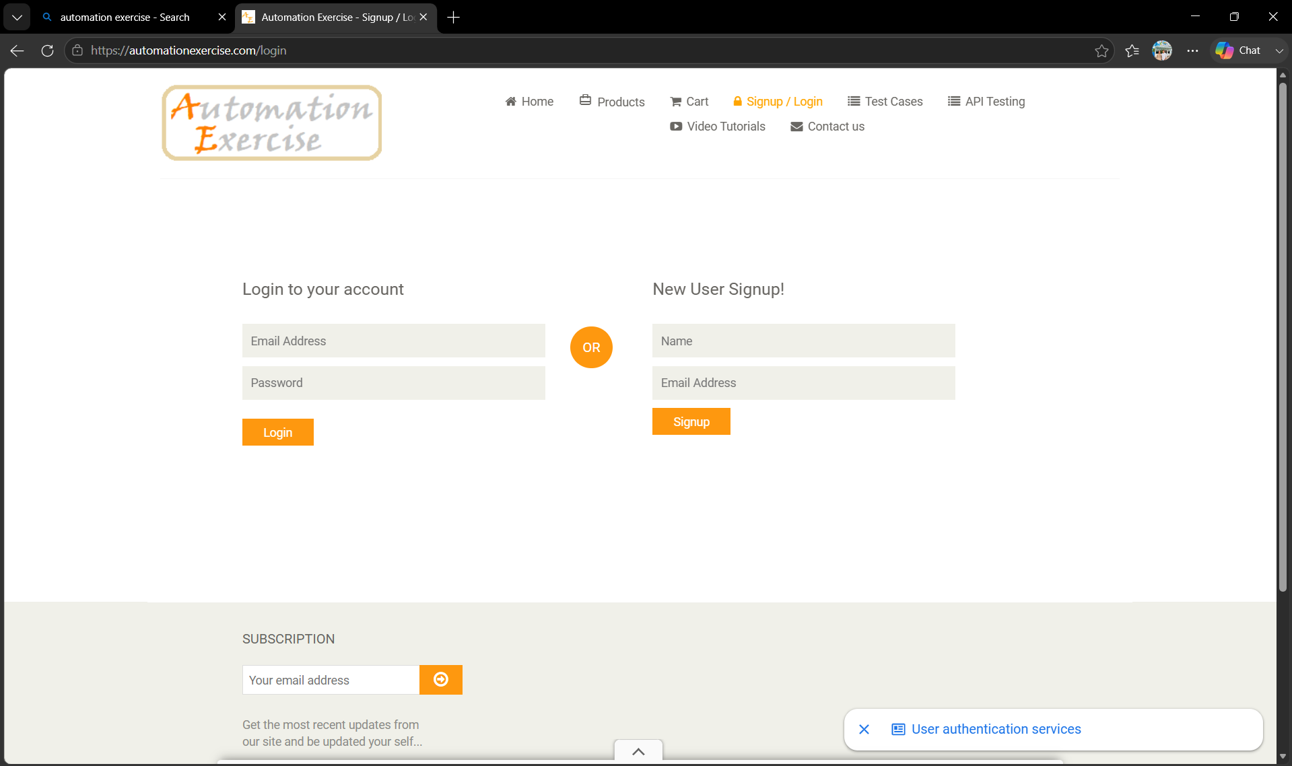

● Scenario ID: 1i
Scenario: Usability check of Login form
Test Steps:
1. Open the Automation Exercise website
2. Click 'Signup / Login'
3. Review field labels, placeholders, and button clarity
Screenshots:
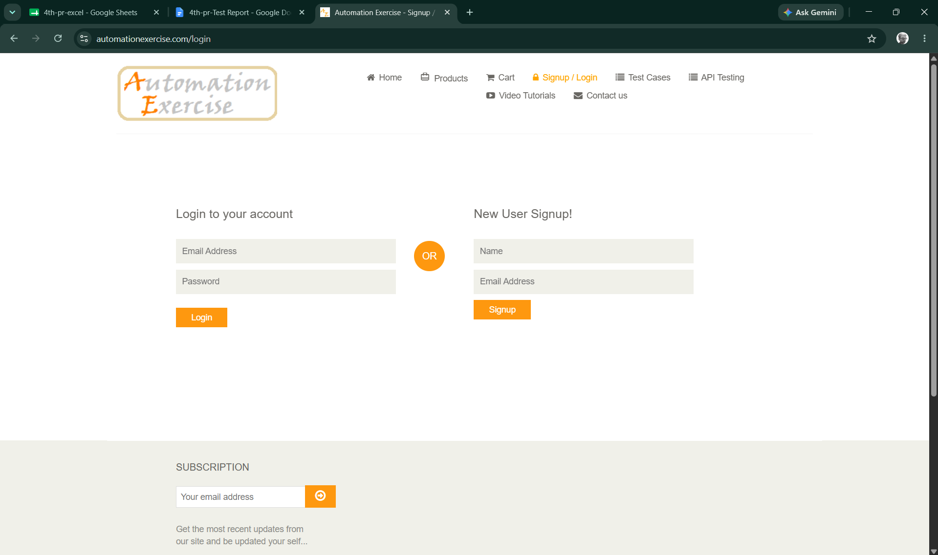

● Scenario ID: 1j
Scenario: Page layout check of Login page
Test Steps:
1. Open the Automation Exercise website
2. Click 'Signup / Login'
3. Verify alignment of fields, labels, and buttons
4. Check for overlapping elements
Screenshots:
Summary of Test Results:
Total Test Cases : 10
Passed : 10
Failed : 0
Not Executed : 0
Pass Rate (%) 100%
Conclusion and Recommendations
Conclusion
All 10 test scenarios for the E-Commerce Website (Automation Exercise) Login Module have been executed successfully with a 100% pass rate. The login functionality is working as expected across all test cases, including valid credentials, invalid credentials, and boundary conditions (blank fields). The suite also confirmed positive results for non-functional checks covering browser compatibility, usability, and page layout. The actual results match the expected results perfectly, indicating that the Login Module is functioning correctly and reliably for the tested scenarios.
Test Coverage Analysis
● Valid credential authentication - PASSED
● Invalid credential rejection - PASSED
● Blank field validation - PASSED
● Error message accuracy - PASSED
● Browser compatibility - PASSED
● Usability of login form - PASSED
● Page layout and alignment - PASSED

Recommendations
● The Login Module is ready for deployment to production with the current functionality.
● Consider implementing additional security features such as rate limiting, account lockout after failed attempts, and CAPTCHA for enhanced protection.
● Add password encryption/hashing to ensure credentials are stored securely.
● Implement session timeout and secure session management protocols.
● Perform penetration testing to identify potential security vulnerabilities.
● Add logging and monitoring for login attempts for audit and security compliance.
● Test with additional scenarios including SQL injection attempts, XSS attacks, and brute force attempts.
● Conduct performance testing under load to ensure the login module scales appropriately.
● Implement two-factor authentication (2FA) for enhanced security.
● Regular security updates and maintenance should be scheduled.

Bug Reports
Summary: No bugs identified during the execution of the 10 test scenarios. All tests passed with expected results matching actual results.

